**Shopping Cart System**

**POC**  
**Low Level Design (LLD)**

**ShopFromHome**

Date: 15/07/2022

Current Document Version: [*1.0*]

DOCUMENT APPROVAL

**Approvers of this document**

|  |  |  |  |  |
| --- | --- | --- | --- | --- |
| **Name** | **Department** | **Role** | **Signature** | **Date** |
|  |  |  |  |  |
|  |  |  |  |  |
|  |  |  |  |  |

**Document Change History**

|  |  |  |  |
| --- | --- | --- | --- |
| **Document Version #** | **Author** | **Date** | **Description** |
| 1.0 | Rutuja Vetal | 15/07/2022 | Shopping Cart System LLD |
|  |  |  |  |
|  |  |  |  |
|  |  |  |  |

Table of Contents

|  |  |  |  |
| --- | --- | --- | --- |
| **Sr no** |  | **Content** |  |
| **1.0** |  | **Document Purpose** |  |
| **2.0** |  | **Intended Audience** |  |
| **3.0** |  | **Project Background, Objective** |  |
|  | **3.1** | **Project Background** |  |
|  | **3.2** | **Project Objective** |  |
| **4.0** |  | **Design Pattern** |  |
| **5.0** |  | **Requirements** |  |
|  | **5.1** | **Hardware** |  |
|  | **5.2** | **Software** |  |
|  | **5.3** | **Specification of other technologies** |  |
| **6.0** |  | **Solution Diagram** |  |
| **7.0** |  | **Solution Steps** |  |
| **8.0** |  | **Classes and Function** |  |
| **9.0** |  | **Validations** |  |
| **10.0** |  | **Data model/ Table** |  |
| **11.0** |  | **Http Status code** |  |
| **12.0** |  | **Er Diagram** |  |
| **13.0** |  | **Unit Testing** |  |
| **14.0** |  | **Use Case Diagram** |  |
| **15.0** |  | **DFD Diagram** |  |

# Document Purpose

This document describes the solution architecture for Shopping Cart System

# Intended Audience

This document is intended as a reference for the following roles and stakeholders who are interested in the Shopping Cart System technical architecture.

|  |  |
| --- | --- |
| Role | Nature of Engagement in WB Classics Portal Technical Architecture |
| Product Owners/SME | Key stakeholder to ensure that the architecture is aligned with business goals. |
| Business Analysts | Business analysts are one of the stakeholders who are informed with the key architectural decisions. |
| Enterprise Architects | To enforce Shopping Cart System Platform Architecture is aligned to business goals and architecture, architectural guidelines. |
| Solution Architects | To ensure solution design and architecture is aligned to business requirements, architectural guidelines. |
| Developers | Use Technical Architecture Document as the guiding document for detail design and implantation approach to align with Customer management Microservice |
| End User | User who browses through products and can order the products |

# Project Background, Objective(s)

## Project Background

Shopping cart system is an Online shopping platform where they can order various products from online sitting at home. Customers register themselves and do shopping of various products, use wallets for payment and see the history of purchase.

## Project Objective

Shopping Cart System will perform various operations like login and register, browse through products, add into cart, wallet payment and see purchase history.

# Design Pattern

|  |  |  |
| --- | --- | --- |
| # | Name | Description |
| 1 | API | Using HTTP requests, we will use the respective action to trigger various operations |
| 2 | Angular | For front-end |
| 3 | SSMS | Database |

1. **Requirements**
   1. **Hardware Requirements**

**Operating System:** Windows 10

**Processor:** x86 or x64

**RAM:** 4GB (minimum), 8GB (recommended)

**Hard Disc:** 32GB (minimum), 64GB (recommended)

* 1. **Software Requirements**

Visual Studio 2019,2022

Visual Studio code

Microsoft SQL Server Management Studio 18

* 1. **Specification of other technologies**

Angular

ASP.NET Web API

HTML 5

CSS 5

Typescript

JavaScript

# 6.0 Solution Diagram

# 

# 7.0 Solution Steps

**User Registration and Login**

1. User will enter the required details such as full Name, image, email, phone number, Date of birth, address, password and click submit button browser directs the request to user registration API
2. call reaches the API gateway
3. After successful registration, user will redirect to the login page.
4. To place the order login is necessary.
5. Validations are provided at the registration.

**Product**

* + - 1. Admin can add the product detail like product name, price, image, description
      2. Product list will be visible for both user and admin
      3. Admin can also perform delete, update the product details using put.
      4. User can use add to cart button to add products in the cart

**Cart**

After browsing through products user will use add to cart button to add products into the cart

There he can increase the quantity of products or can decrease the quantity of products.

He can also remove products from the cart

After that he will click on checkout button to perform further operations

**Payment**

1. After user clicked on checkout button, he will be redirected to Payment page
2. There he has two options cash on delivery and online payment
3. For online payment he can use any e-wallet like credit card, debit card, or upi
4. After successful payment he will redirect to home page
5. He can see order and transaction history

**8.0 Classes/function**

|  |  |  |
| --- | --- | --- |
| # | Class | Description |
| 1 | **User.cs , Product.cs, Cart.cs, Order.cs, Transaction.cs** | **Model for holding the data schema for user, product, cart, order, transaction respectively.** |
| 2 | **Iuser.cs, Iproduct.cs, Icart.cs, Iorder.cs, Itransaction.cs** | **The interface in Data Access Layer for user, product, cart, order, transaction respectively.** |
| 3 | **UserRepo.cs, ProductRepo.cs, CartRepo.cs, OrderRepo.cs, TransactionRepo.cs** | **Implementation of interface for user, product, cart, order, transaction respectively.** |
| 4 | **UserCont.cs, ProductCont.cs, CartCont.cs, OrderCont.cs, TransactionCont.cs** | **Controller handles the incoming HTTP requests and send the response back to the caller.** |
| 5 | **UserSer.cs, ProductSer.cs, CartSer.cs, OrderSer.cs, TransactionSer.cs** | **It is Business Access Layer holding the Business Logic and mediates the communication between the controller and repository.** |

# Validations

**For registration**

User must enter valid information like Name, Email address, Phone number, Password, Address for registration which will inserted into system

**For login**

Admin, Customer can login into system by using proper Email address and Password.

# Data model/Table

|  |  |
| --- | --- |
| Product Table | |
| Name | Datatype |
| ProductID (PK) | INT |
| ProductCategory | VARCHAR |
| ProductName | VARCHAR |
| Price | DECIMAL |
| Description | VARCHAR |
| Image | VARCHAR |

|  |  |
| --- | --- |
| User Table | |
| Name | Datatype |
| UserID (PK) | INT |
| FirstName | VARCHAR |
| LastName | VARCHAR |
| Email | VARCHAR |
| Phone | VARCHAR |
| Password | VARCHAR |

|  |  |
| --- | --- |
| Order Table | |
| Name | Datatype |
| OrderID (PK) | INT |
| CartID (FK) | INT |
| UserID (FK) | INT |
| TotalPrice | DECIMAL |
| ProductID FK) | INT |
| ProductName | VARCHAR |
| Quantity | INT |

|  |  |
| --- | --- |
| Transaction Table | |
| Name | Datatype |
| TransactionID (PK) | INT |
| TotalPrice | DECIMAL |
| TransactionStatus | VARCHAR |
| OrderID (FK) | INT |
| UserID (FK) | INT |
| TransactionType | VARCHAR |

|  |  |
| --- | --- |
| Address Table | |
| Name | Datatype |
| UserID (FK) | INT |
| AddressID (PK) | INT |
| Address | VARCHAR |
| City | VARCHAR |
| State | VARCHAR |
| PIncode | INT |

|  |  |
| --- | --- |
| Cart Table | |
| Name | Data Type |
| CartID (PK) | INT |
| ProductID (FK) | INT |
| ProductName | varchar |
| UserID (FK) | INT |
| Quantity | INT |
| TotalPrice | DECIMAL |

# 

# 11.0 HTTP Status Code

201 – Customer Registered

200 - Request succeeded

400 – Inputs are invalid

404 – Customer Not found

502 – Bad gateway

**12.0 Er Diagram**

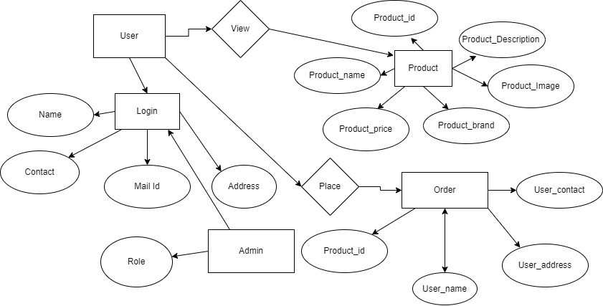

**13.0 Unit Testing**

|  |  |  |  |  |  |  |  |
| --- | --- | --- | --- | --- | --- | --- | --- |
| Test Case Id | TEST CASE SCENARIO | TEST CASE | PRE-CONDITION | TEST STEPS | TEST DATA | EXCEPTED RESULT | ACTUAL RESULT |
| TC 1 | Registration | Enter Valid data to get register | User needs to enter all the valid details | Enter First name, last name, email and every necessary information | Valid details | Successful registration | Successful registration |
| TC 2 | Adding Data | Enter Valid data to add the product | Admin needs to enter all the valid product details | Enter product name, Image, Price, and every necessary information | Valid Details | Successfully added | Successfully added |
| TC 3 | Updating Data | Enter Valid data to Update the product | Admin needs to enter all the valid product details | Enter product name, Image, Price, and every necessary information to update | Valid Details | Successfully  updated | Successfully Updated |
| Tc 4 | Placing Order | Enter valid payment details | User needs to enter all the valid details | Enter address And payment details | Valid Details | Successfully Placed | Successfully Placed |

**14.0 Use Case Diagram**

**15.0 DFD Diagram**



